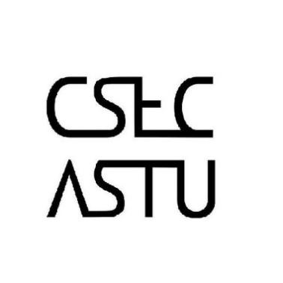 

**Call for all Students who registered for CSEC-Dev’t**

**The entrance exam for CSEC-Dev’t will commence tomorrow evening. As such registered students are expected to attend and participate in this procedure.**

**Venue** – B-508 R-9

**Time**  – Wednesday , November 21, 2018

Attendance is Mandatory!!!